Package in Python

A package is a container that contains various functions to perform specific tasks. For example, the [math](https://www.programiz.com/python-programming/modules/math) package includes the sqrt() function to [perform the square root of a number](https://www.programiz.com/python-programming/examples/square-root).

While working on big projects, we have to deal with a large amount of code, and writing everything together in the same file will make our code look messy. Instead, we can separate our code into multiple files by keeping the related code together in packages.

Now, we can use the package whenever we need it in our projects. This way we can also reuse our code.

Example:

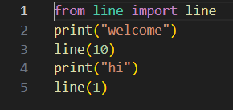

Output:

